Wherever you are on life’s journey,
Know you are welcome here!

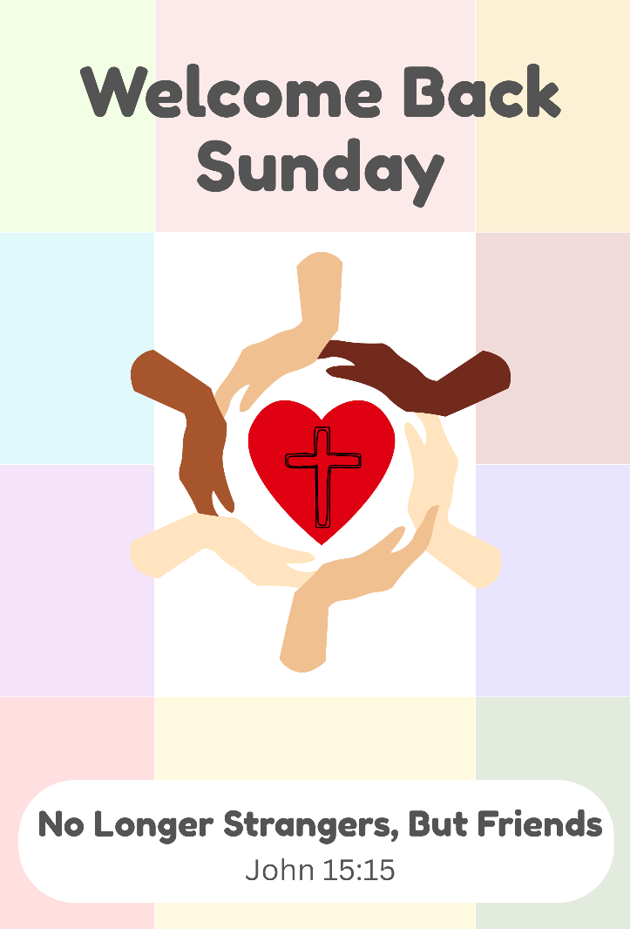

An Open and Affirming Congregation

ORDER OF WORSHIP
Sixteenth Sunday after Pentecost
Sunday, September 13, 2026, at 10:00am
GATHERING MUSIC John Bostron
Music Director

GREETINGS & ANNOUNCEMENTS

PRELUDE & LIGHTING CANDLES Trumpet Voluntary
Andrew Clarke
CALL TO WORSHIP
From John 15 and Jeremiah 38. The congregation standing.
Deacon: Jesus says, “I have called you friends.”
People: We worship as friends of Christ and friends to one another.
Deacon: Welcome to those friends who have been here for years and those who are here for the first time.
People: We worship as God’s people, ready to love, listen, and lend a hand.
Deacon: See what love has been given to us, that in Christ God’s love has been made plain among us.
People: Let us worship the One who calls us friends.

HYMN In Christ There Is No East or West
The congregation stands and sings. New Century Hymnal #395

PRAYER OF INVOCATION & THE LORD’S PRAYER
From John 15 and Jeremiah 38. In unison. The congregation standing.
God of friendship and welcome, you have called us not strangers or servants, but friends. In the world’s eye, we aren't good enough or worthy enough to have this bond; but in your sight, we are exactly who you need. As we begin a new season together, gather us into the joy of your love. We thank you for welcoming us into your household, for giving us your guiding word, and for trusting us with your marvelous work. Make our church a place where people are known, welcomed, and encouraged. Fill us with your generosity and courage so that we may truly be your friends, going forth to notice those in need. Bless us to befriend your world, Lord, and show us how with the prayer Christ gave us to pray together saying,

Our Father, who art in heaven, Hallowed be thy Name. Thy kingdom come. Thy will be done, on earth as it is in heaven. Give us this day our daily bread. And forgive us our debts, as we forgive our debtors. And lead us not into temptation, but deliver us from evil. For thine is the kingdom, and the power, and the glory, forever. Amen.
THE CALL TO CONFESSION
Said by the minister.

PRAYER OF CONFESSION
From John 15 and Jeremiah 38. In unison.
Jesus, our friend, you taught us to abide in your generous love. Yet we do not always make room for others. We have overlooked the hurting, kept to ourselves when we could have reached out, and chosen comfort over courage. Forgive us for having made friendship exclusive. Forgive us, we pray, and teach us your love again. Amen.

ASSURANCE OF GRACE
Deacon: Jesus said to his disciples, “I have called you friends, because I have made known to you everything that I have heard from God. You did not choose me, but I chose you!”
People: Jesus speaks these words to us today. Jesus forgives us and chooses us, sharing his great work of love. Thanks be to God!

THE PEACE
Minister: Before the foundation of the world Christ loved us and made for us a peace that passes all understanding. May the peace of Christ be with you all.
People: And also, with you!

THANK OFFERING
At this time, congregants are invited to share a word of thanksgiving or joy, and to make an offering as an expression of gratitude to God.

A TIME FOR YOUNG PEOPLE
All young people are encouraged to gather at the front of the church for a brief message. Afterwards, young people will go to Sunday School.

ANTHEM Come to Thy Temple
Words by Judge Daniel Clark of Manchester, NH.
Commissioned for the dedication of the Stratham Community Church building, 1837.

SCRIPTURE
Jeremiah 38:7-13 (Pew Bible: page 648-9)
John 15:12-17 (Pew Bible: page 878)

The lessons are read.
Deacon: The Word of the Lord.
People: Thanks be to God.
SERMON Rev. Wesley Conn
Pastor

HYMN Called as Partners in Christ’s Service
The congregation stands and sings. New Century Hymnal #495

PRAYERS OF THE PEOPLE AND PASTORAL PRAYER
We are praying for the family and friends of Susan, the Robodeaux family, Dorothy, Ryan, Mary, Maryann, the family and friends of Vicki, Courtney, the family and friends of Al, the family and friends of Ken George, the Haitian community, Jen, Bob, Angela, all those affected by ICE, the people of Iran, Fred, an end to gun violence in our country, and Natasha.

INVITATION TO OFFERING
Said by the minister.
OFFERTORY John Bostron
Music Director
DOXOLOGY
The congregation stands and sings.
Praise God, from whom all blessings flow.
Praise Him, all creatures here below.
Praise Him above, ye heavenly host.
Praise Father, Son, and Holy Ghost. Amen

PRAYER OF DEDICATION
From John 15 and Jeremiah 38. The congregation standing. In unison.
Pour your Spirit upon these gifts, O God. Send them into the world as a sign of your joyous work of love. Use them to call and welcome into your house all who are your friends and our siblings. Help us, through our giving, our living and our loving, to live up to the challenge of being your friend. Amen.

HYMN What a Friend We Have in Jesus
The congregation stands and sings. Pilgrim Hymnal #335

BENEDICTION
Said by the minister.

POSTLUDE Processional
William Mathias

Thank you to our guest musicians: Courtney Collins, Cajon,
Dave Emanuel, trumpet, Graham Emanuel, trumpet,
Jen Scrafford, Trombone, and John Stewart, Tuba

Leading your worship today are
The Reverend Westley Conn, Pastor, John C. Bostron, Music Director,
Kristen Dusseault and Maria Emanuel, Deacons, and
Jurry Kim, livestream coordinator.

Join us on the front lawn after church for food and fellowship!

One License A-720581.

ANNOUNCEMENTS

Your Church This Week:
Mon. Sept. 14 – Clothes Attic – 10:00am – 2:00pm
Mon, Sept. 14 – Journey Song – 7:00pm – Sanctuary
Tues., Sept. 15 – Lunch & Lectionary – noon – Conference Room
Tues., Sept. 15 – Church Council Retreat – 5:30pm – 8:00pm – Conf. Room
Weds., Sept. 16 – Clothes Attic – 10:00am – 2:00pm
Weds., Sept. 16 – AA Meeting – 7:00pm – Rust Room
Sat., Sept. 19 – Clothes Attic – 10:00am – 2:00pm

Bathrooms
Can be found just outside the sanctuary through the door on the front left. There are also non-gender bathrooms in the Rust Room, found on the lower level. Gendered bathrooms can be found by following the signs to the office outside of the Rust Room.
Be Our Guest!
Join us in the Rust Room (lower level) for conversation and coffee, iced tea, or juice. Follow the crowd or ask a deacon to guide you.

Elevator
An elevator is available for anyone who needs it. To access it, exit the sanctuary using the side door. It is located near the end of the hallway on the right, just beyond the bathroom.

Pastor Wes Sabbatical
As part of his call agreement, Pastor Wes is eligible for a three-month paid sabbatical. Pastor Wes has proposed dividing the three-month sabbatical into two six-week periods over two consecutive summers, beginning in the summer of 2027.

As we continue this planning process, the Church Council would like to hear from you. We invite all members and friends of the congregation to join us for a listening session after church on September 27th, where we’ll share more about the proposed sabbatical plan, answer questions, and listen to your thoughts, ideas, and concerns. More details to come!

October Book Group
Join us after worship on Sundays in October to discuss The Amen Effect by Sharon Brous. Each Discussion will last 40 minutes – come to one or as many as you would like. Books are available at Water Street Bookstore. Email Pastor Wes to register: westleyconn@strathamchurhc.org.

Mental Health Support
The 988 Lifeline: 988 is now active across the United States. (call or text) National Alliance on Mental Illness (NAMI.ORG): information and referral services: 1-800-950-NAMI (6264) Haven NH: support services for domestic violence, sexual assault and stalking 603-994-SAFE (7233) NH Outright: support and resources for the LGBTQIA+ community, https://www.nhoutright.org/.

Giving Online
In the changing landscape of our world, one of the easier ways to give to our church is online. We have a link on our website: www.strathamchurch.org/give, that you can use to make your offering or special donation. To connect to this page, you can use the QR code below.

You can also notify the church if you would like to set up a regular donation to be deducted from your bank account. Please call or email the church office at 772-3389 or findfaith@strathamchurch.org if you would like more information.

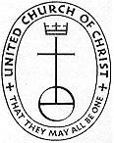

Stratham Community Church, UCC
6 Emery Lane - Stratham, New Hampshire 03885
(603) 772-3389 - www.strathamchurch.org

Ministers - The Congregation
Pastor – The Rev. Westley Conn – WestleyConn@strathamchurch.org
Music Director – John Bostron – Typsichord451@protonmail.com
Sunday School Coordinator – Judy George – george.judy03885@gmail.com
Church Office – Kristen Dusseault – findfaith@strathamchurch.org



The Stratham Community Church is open for worship on Sundays at 10am.
We house both a preschool and thrift shop in our building.
For more information, please visit our website.

