Wherever you are on life’s journey,
Know you are welcome here!

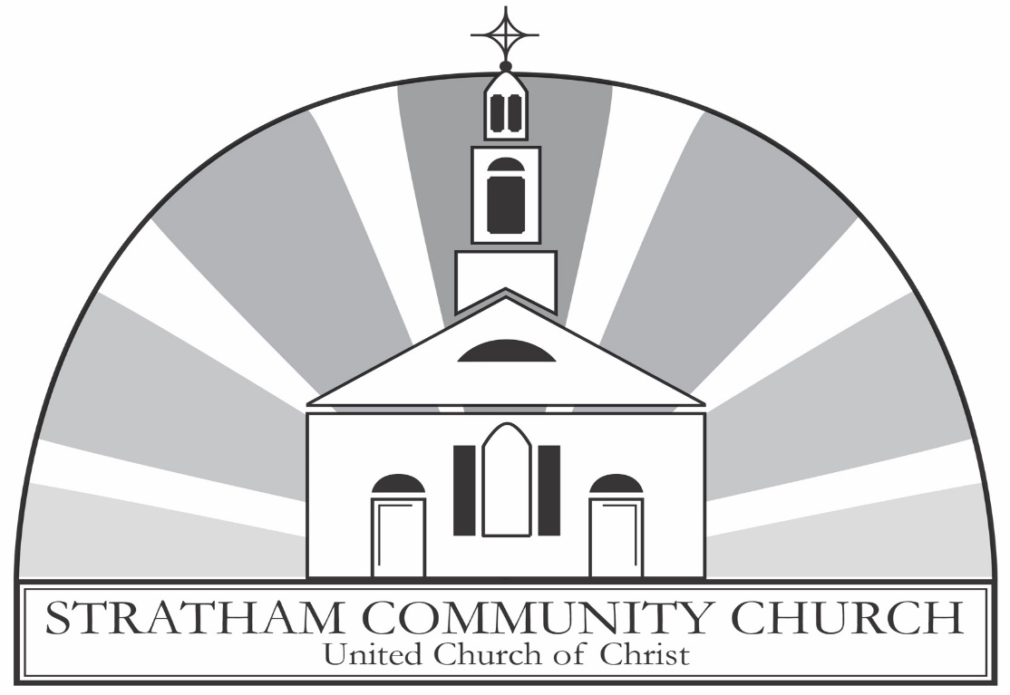

An Open and Affirming Congregation

ORDER OF WORSHIP
Ninth Sunday after Pentecost
Sunday, July 26, 2026, at 9:00am
GATHERING MUSIC Praise Medley
Courtney Collins, cajon

GREETINGS & ANNOUNCEMENTS

PRELUDE & LIGHTING CANDLES Sarabande
Paul Govoni, violin Bach

CALL TO WORSHIP
From Romans 8 & Matthew 13. The congregation standing.
Deacon: The kingdom of God is here. It is like a fine pearl, a mustard seed, a few grains of yeast, a hidden treasure, and a full fishing net.
People: We come before God knowing that God’s kingdom comes in both things small and great.
Deacon: When we do not perceive or understand God’s kingdom, the Holy Spirit intercedes for us.
People: God calls us to take part in the kingdom, to be a part of God’s promise.
Deacon: God’s kingdom is among us, and nothing can separate us from God’s presence.
People: Let us worship the God who knows us and loves us.

HYMN You Are Salt for the Earth, O People
The congregation stands and sings. New Century Hymnal #181

PRAYER OF INVOCATION & THE LORD’S PRAYER
From Romans 8 & Matthew 13. The congregation standing. In unison.
God of mustard seeds and of hidden treasures, as the Apostle Paul has said, sometimes we do not know how to pray. In times like this, give us your Holy Spirit who will turn our sighs into words. Though your kingdom is among us, we do not always recognize it, and at times we might even work against it. Make the teachings of Christ and the wisdom of the Spirit change us to know your kingdom and to build it up in all we do. Be with us in our worship and help us to trust that nothing in all of creation can separate us from your love. When things present or things to come begin to distance us from you, let the words Christ gave us to pray draw us back to you, saying…

Our Father, who art in heaven, Hallowed be thy Name. Thy kingdom come. Thy will be done, on earth as it is in heaven. Give us this day our daily bread. And forgive us our debts, as we forgive our debtors. And lead us not into temptation, but deliver us from evil. For thine is the kingdom, and the power, and the glory, forever. Amen.

THE CALL TO CONFESSION
Said by the minister.

PRAYER OF CONFESSION
From Romans 8 & Matthew 13. In unison.
God of mystery, God of life, we imagine that we are capable judges of power and wisdom and goodness. We trust our own standards, separating and categorizing as we desire. We fail to trust your goodness, hidden in all things. We fail to watch for you, working out your purposes. Transform our lives, Lord, until we yield our lives to your love. Amen.

ASSURANCE OF GRACE
From Romans 8 & Matthew 13.
Deacon: What then are we to say about these things? If God is for us, who is against us?
People: Nothing we have done is enough to separate us from the love of God made known in Jesus Christ; we are forgiven. Thanks be to God!

THE PEACE
Minister: Before the foundation of the world Christ loved us and made for us a peace that passes all understanding. May the peace of Christ be with you all.
People: And also, with you!

THANK OFFERING
At this time, congregants are invited to share a word of thanksgiving or joy, and to make an offering as an expression of gratitude to God.

SPECIAL MUSIC Serenade
Paul Govoni, violin Schubert
SCRIPTURE
Romans 8:26-39 (Pew Bible: page 919-20)
Matthew 13:31-33, 44-52 (Pew Bible: page 795)

The lessons are read.
Deacon: The Word of the Lord.
People: Thanks be to God.

SERMON Reverend Westley Conn
Pastor

HYMN We Plant a Grain of Mustard Seed
The congregation stands and sings. New Century Hymnal #540

PRAYERS OF THE PEOPLE AND PASTORAL PRAYER
After each intercession,
Minister: Lord in your mercy,
People: hear our prayer.
We are praying for Vicki, Bill & Sandy, Courtney, Grace, the family and friends of Ken George, the Haitian community, Betty, the family and friends of Tish, Jen, Matt, Maryann, the family and friends of Jane, Bob, Angela, all those affected by ICE, Linda, the people of Iran, Fred, an end to gun violence in our country, and Natasha.

INVITATION TO OFFERING
Said by the minister.

OFFERTORY John C. Bostron
Music Director

DOXOLOGY
The congregation stands and sings.
Praise God, from whom all blessings flow.
Praise Him, all creatures here below.
Praise Him above, ye heavenly host.
Praise Father, Son, and Holy Ghost. Amen

PRAYER OF DEDICATION
From Romans 8 & Matthew 13. The congregation standing. In unison.
God of small things, Christ taught us that even the tiniest of seeds can have a great impact. We give you our gifts knowing no matter how small they are or how small they seem, that you will bless them and use them according to your purpose. In our giving, bless us that in our generosity we would come to live in your kingdom. Amen.

HYMN Lead On Eternal Sovereign
The congregation stands and sings. New Century Hymnal #573

BENEDICTION
Said by the minister.

POSTLUDE Ashokan Farewell
Paul Govoni, violin Jay Unger

Thank you to Courtney Collins and Paul Govoni for sharing their
musical talents with us this morning!

Leading your worship today are
The Reverend Westley Conn, Pastor, John C. Bostron, Music Director,
Bob Butcher and Dennis Green, Deacons, and
Maria Emanuel, livestream coordinator.

One License A-720581.

ANNOUNCEMENTS

Your Church This Week:
Mon. July 27 – Clothes Attic – 10:00am – 2:00pm
Mon, July 27 – Journey Song – 7:00pm – Sanctuary
Tues., July 28 – Lunch & Lectionary – noon – Conference Room
Tues., July 28 – Pray & Prune – 6:30pm – Community Garden, 10 Bunker Hill
Weds., July 29 – Clothes Attic – 10:00am – 2:00pm
Weds., July 29 – AA Meeting – 7:00pm – Rust Room
Sat., Aug. 1 – Clothes Attic – 10:00am – 2:00pm

Bathrooms
Can be found just outside the sanctuary through the door on the front left. There are also non-gender bathrooms in the Rust Room, found on the lower level. Gendered bathrooms can be found by following the signs to the office outside of the Rust Room.

Be Our Guest!
Join us in the Rust Room (lower level) for conversation and coffee, iced tea, or juice. Follow the crowd or ask a deacon to guide you.

Elevator
An elevator is available for anyone who needs it. To access it, exit the sanctuary using the side door. It is located near the end of the hallway on the right, just beyond the bathroom.

Lay Preaching
“God in the Ordinary.” Hear from members of our church this summer as they reflect on where they’ve noticed God in everyday moments: August 23, Cyndi McCleary.

Pray and Prune
Join Pastor Wes at 6:30pm on Tuesdays in July at the Stratham Community Garden, 10 Bunker Hill Ave, to tend our flowers and veggies, then pray with the psalms and nature.

Allan Lurvey Memorial Golf Scramble
The Allan Lurvey Memorial Golf Scramble to benefit the Seacoast Area CROP walk will be held on August 21 at the Breakfast Hill Golf Course in Greenland, NH. The deadline for golfers to register is August 7. Non-golfers can register for lunch only. For more information, or to register, please visit the website at:
https://allan-lurvey-memorial.perfectgolfevent.com/



Mental Health Support
The 988 Lifeline: 988 is now active across the United States. (call or text) National Alliance on Mental Illness (NAMI.ORG): information and referral services: 1-800-950-NAMI (6264) Haven NH: support services for domestic violence, sexual assault and stalking 603-994-SAFE (7233) NH Outright: support and resources for the LGBTQIA+ community, https://www.nhoutright.org/.

Giving Online
In the changing landscape of our world, one of the easier ways to give to our church is online. We have a link on our website: www.strathamchurch.org/give, that you can use to make your offering or special donation. To connect to this page, you can use the QR code below.

You can also notify the church if you would like to set up a regular donation to be deducted from your bank account. Please call or email the church office at 772-3389 or findfaith@strathamchurch.org if you would like more information.

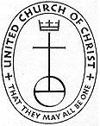

Stratham Community Church, UCC
6 Emery Lane - Stratham, New Hampshire 03885
(603) 772-3389 - www.strathamchurch.org

Ministers - The Congregation
Pastor – The Rev. Westley Conn – WestleyConn@strathamchurch.org
Music Director – John Bostron – Typsichord451@protonmail.com
Sunday School Coordinator – Judy George – george.judy03885@gmail.com
Church Office – Kristen Dusseault – findfaith@strathamchurch.org



The Stratham Community Church is open for worship on Sundays at 10am.
We house both a preschool and thrift shop in our building.
For more information, please visit our website.

