Wherever you are on life’s journey,
Know you are welcome here!

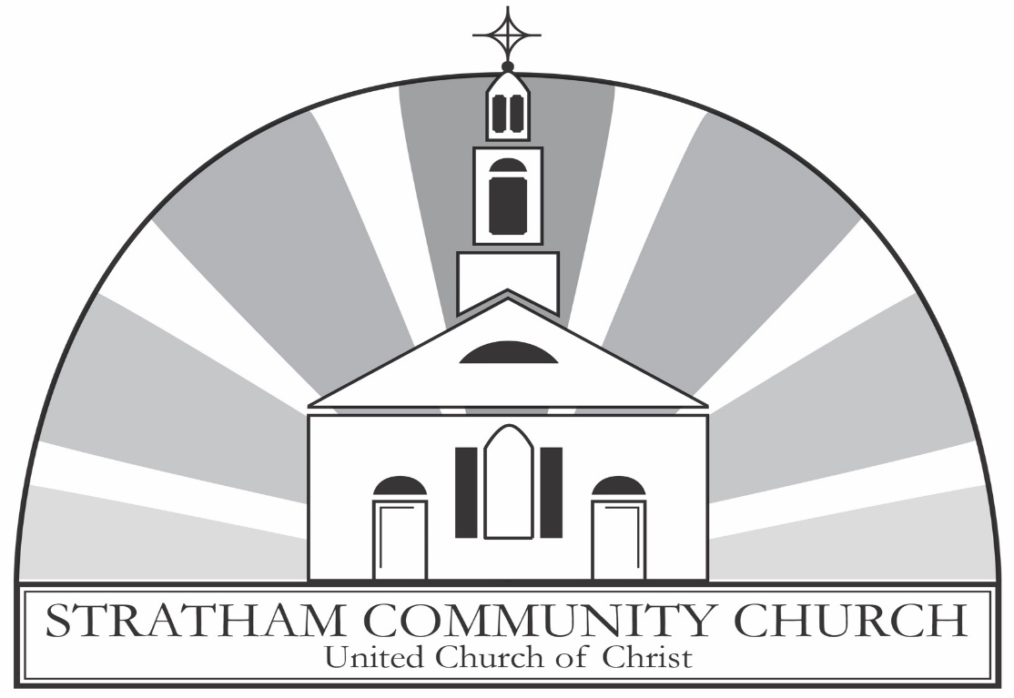

An Open and Affirming Congregation

ORDER OF WORSHIP
Third Sunday of Easter
Earth Sunday
Sunday, April 19, 2026, at 10:00am
GATHERING MUSIC John C. Bostron
Music Director

GREETINGS & ANNOUNCEMENTS

PRELUDE & LIGHTING CANDLES Pastorale in F
1.
J.S. Bach

CALL TO WORSHIP
The congregation standing.
Deacon: I saw the Lord always before me. Because he is at my right hand, I will not be shaken.
People: Therefore, my heart is glad and my tongue rejoices; my body also will be in hope.
Deacon: Because you will not abandon me to the realm of the dead, you will not let your holy one see decay.
People: You have made known to me the paths of life; you will fill me with joy in your presence.
Deacon: As we continue to rejoice in the miracle of your Son’s resurrection, our hearts are filled with hope and joy.
People: May we sing your praises on the day, and on all the days to come.

HYMN The Day of Resurrection
The congregation stands and sings. New Century Hymnal #245

PRAYER OF INVOCATION & LORD’S PRAYER
In unison. The congregation standing.
When the challenges of the day lead us to a place where our faith begins to waiver, we turn to you, O God, the center of our hope. Prayer elevates us from the places where questions and doubts are hiding, waiting for us to be vulnerable to darkness and despair. The Good News of the Resurrection gives us the strength to persevere and to overcome, that we might be your people in this world. Let us be those people, O God, for we long to be the ones who bring the light of your truth, your glory, your mercy, your love and your hope. We are the children born of your promises that, together, we can make a difference as we work toward the reality of your Blessed Community. Hear us now, as we pray together the words Jesus gave his disciples.

Our Father, who art in heaven, Hallowed be thy Name. Thy kingdom come. Thy will be done, on earth as it is in heaven. Give us this day our daily bread. And forgive us our debts, as we forgive our debtors. And lead us not into temptation but deliver us from evil. For thine is the kingdom, and the power, and the glory, forever. Amen.

CALL TO CONFESSION
Said by the minister.

PRAYER OF CONFESSION
In unison.
How many times, O Christ, have you stood before us, but our eyes were not open to your holy presence in our midst. We yearn to be faithful followers, even while we forget that in following, we are also to be ministers of your word. When we falter, when our eyes do not behold, when our minds rush to judgment, remind us that none of us stands alone, that sometimes our eyes need corrective vision, and that judgment is not ours to pronounce. Bless us as we labor to learn this anew as your Easter people. Amen.

ASSURANCE OF GRACE
Deacon: Beloveds, hear this word of Easter hope. We are loved beyond our limited knowledge and cherished always as beloved children of God and followers of the Christ. The assurance of faith is that we are accepted and loved by the Creator just as we have been created.
People: Easter hope and joy fill our hearts as we remember the promises made and kept during this holy season of redemption and love. Amen.

THE PEACE
Minister: Before the foundation of the world Christ loved us and made for us a peace that passes all understanding. May the peace of Christ be with you all.
People: And also, with you!

THANK OFFERING
At this time, congregants are invited to share a word of thanksgiving or joy, and to make an offering as an expression of gratitude to God.

ANTHEM Thank You, God Brian Wren/John Weaver
SCRIPTURE
Acts 2:14a, 36-41 (Pew Bible: page 885-6)
Luke 24:13-35 (Pew Bible: page 860-1)

The lessons are read.
Deacon: The Word of the Lord.
People: Thanks be to God.
SERMON Rev. Gail Kindberg
Guest Preacher

HYMN Thine is the Glory
The congregation stands and sings. Pilgrim Hymnal #193

PRAYERS OF THE PEOPLE AND PASTORAL PRAYER
Said by the minister.
We are praying for Allie, the family and friends of Jim, the family and friends of Cory, Courtney, all those struggling with cancer, Steve, Bill, Chase and his parents, Ellen, David, Angela, Jordan, Wesley, and the troops deployed in the middle east, all those affected by ICE, Linda, the people of Iran, Fred, Vicki, an end to gun violence in our country, Caitlin, and Natasha.

INVITATION TO OFFERING
Said by the minister.
OFFERTORY John C. Bostron Music Director

DOXOLOGY
The congregation stands and sings.
Praise God, from whom all blessings flow.
Praise Him, all creatures here below.
Praise Him above, ye heavenly host.
Praise Father, Son, and Holy Ghost. Amen

PRAYER OF DEDICATION
The congregation standing.
We bring our gifts, both tangible and intangible, and pledge them to your service, O God. Bless all that we offer, as these are the gifts of our hearts. Open our eyes and our minds to the needs of the community, both near and far, and increase our generosity of spirit as we seek to see you in the presence of others and strive to make a difference rooted in love and compassion. Walk with us each day, as Jesus walked with those on the way to Emmaus, reminding us that every interaction is an opportunity to invite and inspire others to join us on the journey of life that leads to new beginnings in faith. Amen.

THE BLESSING OF THE SEEDS
In unison. The congregation standing.
Creator and Creating God, you have formed heaven and earth, and our very selves from the Earth. Bless these seeds, saplings, and plants to bear good fruit. May their growing and greening call us to be caretakers of your creation. Keep us amazed in gratitude for the beauty of the earth and for those who steward it. Let these good things bring us to tend to those without adequate water and food. This we pray in the name of Christ, who like the green grass, rose from the buried grain. Amen.

HYMN In the Bulb There Is a Flower
The congregation stands and sings. New Century Hymnal #433
BENEDICTION
Said by the minister.
POSTLUDE Pastorale in F
4.
J.S. Bach

Leading your worship today are
The Rev. Gail Kindberg, Guest Preacher, John C. Bostron, Music Director,
Dennis Green, and Pamela Hollasch, Deacons, and
Bev David, livestream coordinator.

One License A-720581.

ANNOUNCEMENTS

Your Church This Week:
Mon., Apr. 20 – Clothes Attic – 10:00am – 2:00pm
Mon, Apr. 20 – Journey Song – 7:00pm – Sanctuary
Tues., Apr. 21 – NO Lunch & Lectionary
Tues., Apr. 21 – Church Council – 7:00pm – Zoom
Weds., Apr. 22 – Clothes Attic – 10:00am – 2:00pm
Weds., Apr. 22 – AA Meeting – 7:00pm – Rust Room
Thurs. Apr. 23 – Choir Rehearsal – 6:30pm – Sanctuary
Sat., Apr. 25– Clothes Attic – 10:00am – 2:00pm

Be Our Guest!
Join us in the Rust Room (lower level) for conversation and coffee, iced tea, or juice. Follow the crowd or ask a deacon to guide you.

Bathrooms
Can be found just outside the sanctuary through the door on the front left. There are also non-gender bathrooms in the Rust Room, found on the lower level. Gendered bathrooms can be found by following the signs to the office outside of the Rust Room.
Elevator
An elevator is available for anyone who needs it. To access it, exit the sanctuary using the side door. It is located near the end of the hallway on the right, just beyond the bathroom.

Lunch and Lectionary on Hiatus
Lunch and Lectionary will be on hiatus Tuesday, April 21st. Please join Pastor Wes on Tuesday, April 28th, at noon to discuss the week's scripture lessons. Bring your lunch and Bible. We will meet in the conference room.

Community Garden
Support our SCC Garden Group by volunteering to be a steward. Stewards take turns tending our garden plot, helping to grow produce for a food pantry or a church supper. For more information about volunteering or to become a steward, please email Pastor Wes at westleyconn@strathamchurch.org.

Pastor Wes away
Pastor Wes will be away at his NGLI program April 12 through April 20. Should you need emergency pastoral care, please contact a deacon or the church office at (603) 772-3389.

Mental Health Support
The 988 Lifeline: 988 is now active across the United States. (call or text) National Alliance on Mental Illness (NAMI.ORG): information and referral services: 1-800-950-NAMI (6264) Haven NH: support services for domestic violence, sexual assault and stalking 603-994-SAFE (7233) NH Outright: support and resources for the LGBTQIA+ community, https://www.nhoutright.org/.

Weekly Newsletter
Every Thursday, we send out a newsletter called the SCC News. The newsletter has information about upcoming events at our church and in the community. If you’d like to receive the newsletter, email the church office at findfaith@strathamcommunitychurch.org or click on the link below.


Giving Online
In the changing landscape of our world, one of the easier ways to give to our church is online. We have a link on our website: www.strathamchurch.org/give, that you can use to make your offering or special donation. To connect to this page, you can use the QR code below.

You can also notify the church if you would like to set up a regular donation to be deducted from your bank account. Please call or email the church office at 772-3389 or findfaith@strathamchurch.org if you would like more information.


Stratham Community Church, UCC
6 Emery Lane - Stratham, New Hampshire 03885
(603) 772-3389 - www.strathamchurch.org

Ministers - The Congregation
Pastor – The Rev. Westley Conn – WestleyConn@strathamchurch.org
Music Director – John Bostron – Typsichord451@protonmail.com
Sunday School Coordinator – Judy George – george.judy03885@gmail.com
Church Office – Kristen Dusseault – findfaith@strathamchurch.org



The Stratham Community Church is open for worship on Sundays at 10am.
We house both a preschool and thrift shop in our building.
For more information, please visit our website.

