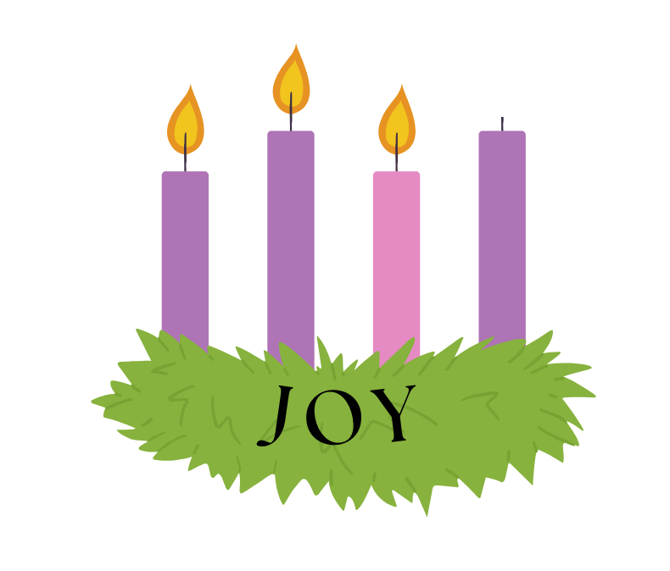

ORDER OF WORSHIP
Third Sunday of Advent
Sunday, December 14, 2025, at 10:00am
GATHERING MUSIC John Bostron, MM
Music Director

GREETINGS & ANNOUNCEMENTS

PRELUDE & LIGHTING OF CANDLES Let All Mortal Flesh Keep Silence
Maria Emanuel, piano, Paul Govoni, violin, trad./arr. Catherine McMichael
Steve Grasberger, viola

THE LIGHTING OF THE ADVENT WREATH The Dupell Family
We light the candle representing Joy.
One: Advent is a time to watch. We look for God’s glory and good news.
Many: We watch for God’s salvation, which brings good news to the oppressed, liberty to the captives, and release to the prisoners.
One: God’s joy provides for those who mourn, giving them a heart of praise instead of a faint spirit. They will become a display of God’s glory.
Many: Let us keep watch together for the coming of Jesus, the Christ, whose presence makes all things sing for joy.
One: God of Glory, you are on the horizon. We light this candle of joy, that we would rejoice always in the Lord.

HYMN O Come, O Come, Emmanuel
The congregation stands and sings. Pilgrim Hymnal #110 (vs 1,2&3)

CALL TO WORSHIP
From James 5 and Matthew 1. The congregation standing.
Deacon: In a world eager for quick answers, God invites us to wait with holy patience.
People: We come, like farmers watching the earth, trusting God to bring new life.
Deacon: In the quiet of our waiting, Emmanuel —God with us, God for us— draws near.
People: Let us prepare our hearts to receive the One who brings salvation and peace.
Deacon: Like Joseph, let us open our hearts to what God is doing.
People: With expectation and joy, we worship God

HYMN In the Bleak Midwinter
The congregation stands and sings New Century Hymnal #128.
PRAYER OF INVOCATION & THE LORD’S PRAYER
From James 5 and Matthew 1. In unison. The congregation standing.
Almighty and Everlasting God, we gather with restless hearts, yet our faith reminds us that you are at work even when we cannot know the whole story. By your word and the power of the Holy Spirit, teach us the kind of patience of which James speaks; the kind anchored in trust, not in fear. As your servant, Joseph paid attention to your heavenly messenger and welcomed your holy purpose, so may we listen for your voice and desire your will. Be with us now. Fill our worship with your presence, your encouragement, and your joy. And when the restlessness of our lives muddles your voice, let us find clarity in the words Christ gave us to pray together saying,

Our Father, who art in heaven, Hallowed be thy Name. Thy kingdom come. Thy will be done, on earth as it is in heaven. Give us this day our daily bread. And forgive us our debts, as we forgive our debtors. And lead us not into temptation, but deliver us from evil. For thine is the kingdom, and the power, and the glory, forever. Amen.

THE PEACE
Minister: Before the foundation of the world Christ loved us and made for us a peace that passes all understanding. May the peace of Christ be with you all.
People: And also, with you.

THANK OFFERING
At this time, congregants are invited to share a word of thanksgiving or joy, and to make an offering as an expression of gratitude to God.

ANTHEM Advent Alleluia trad./arr. P. Liebergen

SCRIPTURE
James 5:7-10 (Pew Bible: page 982)
Matthew 1:18-25 (Pew Bible: page 783)

The lessons are read.
Deacon: The Word of the Lord.
People: Thanks be to God.

SERMON Reverend Westley Conn
Pastor

HYMN Gentle Joseph, Joseph Dear
The congregation stands and sings. New Century Hymnal #105

PRAYERS OF THE PEOPLE AND PASTORAL PRAYER
Said by the minister.
We are praying for Sheri, David, the family and friends of Matthew, Tim, people in fear of being deported, Vicki, the family and friends of Michael, Tina, the family and friends of Joan Holmes, the family and friends of Shirley, the Driscoll family, Donna, an end to gun violence in our country, Caitlin, Sam, Sara, our transgender friends and family, and Natasha.

INVITATION TO OFFERING
Said by the minister.

OFFERTORY John C. Bostron, MM

DOXOLOGY
The congregation stands and sings.
Praise God, from whom all blessings flow.
Praise Him, all creatures here below.
Praise Him above, ye heavenly host.
Praise Father, Son, and Holy Ghost. Amen.

PRAYER OF DEDICATION
From James 5 and Matthew 1. The congregation standing. In unison.
Holy God, you bless us with many gifts, you retrieve us from despair and fear, and visit us with surprising words of joy. We thank you for your steadfast love, for sending signs of assurance, and for the gift of faith. Like Joseph, we want to do our part in bringing your light and life into the world, and so we offer you these gifts for the sake of new life. Amen.

HYMN People Look East
The congregation stands and sings. insert

BENEDICTION

POSTLUDE Lo, How a Rose
Maria Emanuel, piano, Paul Govoni, violin, trad., arr. Catherine McMichael
Steve Grasberger, viola

Special thank you to the Dupell family for lighting the Advent candles,
and our guest musicians, Maria Emanuel, Paul Govoni and Steve Grasberger
for sharing their talents this morning.

Leading your worship today are
The Reverend Westley Conn, Pastor, John Bostron, MM, Music Director,
Bob Butcher and Carol Hawks, Deacons, and
Maria Emanuel, Live-stream coordinator.

One License A-720581.

ANNOUNCEMENTS
Your Church This Week:
Sun., Dec. 14 – Confirmation – 4:00 – 5:30pm, SCC
Mon., Dec. 15 – Journey Song – 7:00 – 8:00pm – Sanctuary
Tues., Dec. 16 – Lunch & Lectionary – noon – Conference Room
Tues., Dec. 16 – Church Council – 7:00pm – Zoom
Weds., Dec. 17 – Clothes Attic – 10:00am – 2:00pm
Weds., Dec. 17 – AA Meeting – 6:30pm – Rust Room
Thurs., Dec. 18 – Choir Rehearsal – 6:00pm -- Sanctuary
Sat., Dec. 20 – Clothes Attic – 10:00am – 2:00pm

Bathrooms
Can be found just outside the sanctuary through the door on the front left. There are also non-gender bathrooms in the Rust Room, found on the lower level. Gendered bathrooms can be found by following the signs to the office outside of the Rust Room.

Be Our Guest!
Join us in the Rust Room for coffee or tea or another beverage, a bite to eat, and conversation. The Rust Room is found on the lower lever of the church. Follow the crowds or ask a deacon to guide you.
Christmas Eve at SCC
This year we will have one Christmas Eve Service at 6:00pm; which will include a time for young people, candlelight, choir and communion. Be with us to worship Emmanuel, God with us.
New Members
A new member class is forming. If you are interested in joining our church, or learning more about the process, please contact Pastor Wes at WestleyConn@strathamchurch.org.

Mental Health Support
The 988 Lifeline: 988 is now active across the United States. (call or text) National Alliance on Mental Illness (NAMI.ORG): information and referral services: 1-800-950-NAMI (6264) Haven NH: support services for domestic violence, sexual assault and stalking 603-994-SAFE (7233) Seacoast Outright: support and resources for the LGBTQIA+ community, seacoastoutright.org.
Christmas Memorial Poinsettias
If you would like to donate towards the Sanctuary flowers during this Christmas season, please let the church office know the following information:
Your Name, In Memory of, or In Honor of whom, Contribution amount.
Your name & the names of your loved ones will be included in our bulletin on Sunday, December 21. You may also complete a form located in the narthex and put it in the offertory plate.

Bright Gifts for Seacoast Family Promise
Please sign up for the Statham Community Church Bright Gift Sunday and support the families of Seacoast Family Promise this Christmas. Wrap your gifts in bright, colored wrapping paper and mark a gift tag as noted:
To: the first name of the recipient
From: leave blank
Bring your gifts to church on Sunday, December 21st for Children’s Pageant Sunday. If you gifts need to be dropped off earlier to the church office, please call ahead for an appointment (603.772.3389). For more information or questions, contact the church office or Marny Keith (marnyguatemala@gmail.com). You can follow this link to sign up online: https://bit.ly/4oFUP6B.

Giving Online
In the changing landscape of our world, one of the easier ways to give to our church is online. We have a link on our website: www.strathamchurch.org/give, that you can use to make your offering or special donation. To connect to this page, you can use the QR code below.



You can also notify the church if you would like to set up a regular donation to be deducted from your bank account. Please call or email the church office at 772-3389 or findfaith@strathamchurch.org if you would like more information.

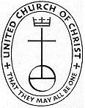
Stratham Community Church, UCC
6 Emery Lane - Stratham, New Hampshire 03885
(603) 772-3389 - www.strathamchurch.org

Ministers - The Congregation
Pastor – The Rev. Westley Conn – WestleyConn@strathamchurch.org
Music Director – John Bostron, MM – johnc.bostron@protonmail.com
Sunday School Coordinator – Judy George – george.judy03885@gmail.com
Church Office – Kristen Dusseault – findfaith@strathamchurch.org



The Stratham Community Church is open for worship on Sundays at 10am.
We house both a preschool and thrift shop in our building.
For more information, please visit our website.

