Wherever you are on life’s journey,
Know you are welcome here!

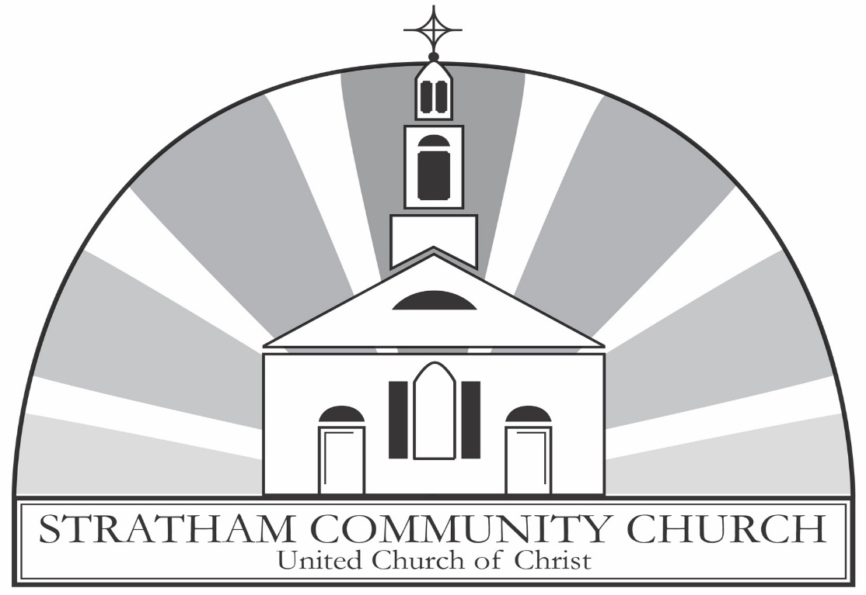
An Open and Affirming Congregation

ORDER OF WORSHIP
Thirteenth Sunday after Pentecost
Sunday, August 18, 2024, at 9:00am
GATHERING MUSIC John C. Bostron, MM
Music Director
GREETINGS & ANNOUNCEMENTS
PRELUDE & LIGHTING CANDLES Aria
Flor Peeters

CALL TO WORSHIP
From Exodus 35 and Psalm 149. The congregation standing.
Deacon: Sing praises to the Lord. Gather together and offer praises to God in this place.
People: God has called us by name and has provided us with the Spirit so that we can rejoice in our Creator.
Deacon: All you faithful people, praise our glorious Lord. With hands, hearts, and minds celebrate and worship God.
People: We have been given skill, intelligence, and knowledge of every kind to praise our God.
Deacon: With song and cymbal make praises to our Maker, for God takes pleasure in us.
People: Let our mouths be filled with God’s praises. Let us sing a song to God.

HYMN O, Grant Us God, A Little Space
The congregation stands and sings. New Century Hymnal #516
PRAYER OF INVOCATION & LORD’S PRAYER
From Exodus 35 and Psalm 149. In unison.
Maker of all that was and is and is to come, you have made us to be your co-creators and stewards of goodness. Speak to us in the beauty of our worship and let our mouths be filled with your praises. Lord, you have given each of us skill, intelligence, and knowledge in every kind of craft. Show us how to use our creativity to tell of your goodness, that everything from our music-making to baking would proclaim your mercies. As you dwell with us today, make your Holy Spirit come alongside us to point out your presence in our midst each day. Join our hands with yours in filling the world with beautiful things, like the prayer Christ gave us to pray together saying,
Our Father, who art in heaven, Hallowed be thy Name. Thy kingdom come. Thy will be done, on earth as it is in heaven. Give us this day our daily bread. And forgive us our debts, as we forgive our debtors. And lead us not into temptation but deliver us from evil. For thine is the kingdom, and the power, and the glory, forever. Amen.

THE PEACE
Minister: Before the foundation of the world Christ loved us and made for us a peace that passes all understanding. May the peace of Christ be with you all.
People: And also, with you!
THANK OFFERING
At this time, congregants are invited to share a word of thanksgiving or joy, and to make an offering as an expression of gratitude to God.
ANTHEM Cornet Voluntary
John Travers
SCRIPTURE
Exodus 35:30-36:1 (Pew Bible: page 72-73)
Psalm 149 (Pew Bible: page 508)
The lessons are read.
Deacon: The Word of the Lord.
People: Thanks be to God.
SERMON Maria Emanuel, Lay Preacher

HYMN Colorful Creator
The congregation stands and sings. New Century Hymnal #30
PRAYERS OF THE PEOPLE AND PASTORAL PRAYER
Said by the minister.
After each intercession.
Minister: Lord in your mercy,
People: hear our prayer.
We are praying for John, families in distress, the family and friends of Bob Kennedy, Audrey, Joel, Laurie and her family, the family and friends of Leon, Ralph, the family and friends of Ron Chisholm, Curt, Don, George, Tom, Barb, Mrs. Kim, Tim, Megan, Natasha, and Babs.
INVITATION TO OFFERING
Said by the minister.
OFFERTORY John C. Bostron, MM
Music Director
DOXOLOGY
The congregation stands and sings.
Praise God, from whom all blessings flow.
Praise Him, all creatures here below.
Praise Him above, ye heavenly host.
Praise Father, Son, and Holy Ghost. Amen.
PRAYER OF DEDICATION
From Exodus 35 and Psalm 149. The congregation standing. In unison.
Lord, we praise you with song and dancing, with crafts and carvings, and now we praise you with the offering of our tithes. Receive these gifts and all that we create for you. Bless them to be a sign of your beautiful presence for all people. Let our offering this day remind us of the intellect and creativity we have to offer you each day. Amen.

HYMN Take My Gifts
The congregation stands and sings. New Century Hymnal #562
BENEDICTION
POSTLUDE Jubilee on ‘Foundation’
Carson Cooman

Leading your worship today are
The Rev. Westley Conn, Pastor, John C. Bostron, MM, Music Director,
Laura Batchelder and Bob Butcher, Deacons,
Carol Hawks, Live Stream Coordinator.

One License A-720581.

ANNOUNCEMENTS

Your Church This Week:
Mon., Aug. 19 – Story Strolls – 6:30pm – Stratham Hill Park
Mon., Aug. 19 – Journey Song – 7:00 – 8:00pm – Sanctuary
Tues., Aug. 20 – Lunch & Lectionary – noon – conference room
Tues., Aug. 20 – AA Meeting – 7:00pm – Rust Room
Weds., Aug. 21 – Clothes Attic – CLOSED
Thurs., Aug. 22 – Back to Sunday School Camp – 9:00am – 3:00pm
Sat., Aug. 24 – Clothes Attic – CLOSED

Be Our Guest!
Join us in the Rust Room for coffee or tea or another beverage, a bite to eat, and conversation. The Rust Room is found on the lower lever of the church. Follow the crowds or ask a deacon to guide you.
Bathrooms
Can be found just outside the sanctuary through the door on the front left. There are also non-gendered bathrooms in the Rust Room, found on the lower level. Gendered bathrooms can be found by following the signs to the office outside of the Rust Room.
Elevator
An elevator is available for anyone who needs it. To access it, exit the sanctuary using the side door. It is located near the end of the hallway on the right, just beyond the bathroom.
Story Strolls
Gather with us throughout August to walk on one of the trails in Stratham Hill Park on Mondays at 6:30pm. We will meet in front of the pavilion, near the primary parking lot. Please note this outing is weather-dependent. If it is raining, catch us the next Monday!

Back to Sunday School Camp
All young people are invited to join us for a daylong camp at SCC on Thursday, August 22 from 9:00am to 3:00pm. We will read the story of Noah's Ark and have crafts and games centered around an animal theme, since our Sunday School coordinator, Judy George, will have just returned from an African safari and will be excited to share stories and pictures! Please bring a lunch, we have snacks to share. To register, email the church office at findfaith@strathamchurch.org.
Save the Date!
Welcome Back Sunday is on Sunday, Sept. 8 at 10:00am. Help us dedicate our new organ in memory of the late Sally Wool and stay afterwards for food and games.

Seacoast Youth Fellowship
Pastor Wes and Pastor Jenn (Portsmouth, UCC) are offering youth group for UCC congregations in the Seacoast. All young people in grades 8 through 12 are invited to bring their friends to our first gathering on Sunday, September 22 from 3:30-5:00pm at SCC. Let Pastor Wes know that you'll be there: westleyconn@strathamchurch.org.

Read Along With Pastor Wes
Scan the code below or follow this link: https://bit.ly/3WkbYs8 to see what Pastor Wes is reading this summer. If there’s a book on the list that you’d like to read with him, let him know at westleyconn@strathamchurch.org.

Sing With Us!
Stratham Community Church choir season begins on Thursday, August 29 at 7pm for rehearsal. All voices are welcome! Please see John Bostron, our music director, with any questions. (johncbostron@protonmail.com)

Open and Affirming Anniversary
The Open and Affirming Anniversary Committee has been meeting to plan what it means to be an open and affirming church and to celebrate 20 years of doing so at the Stratham Community Church! In addition to a celebration, speakers and book groups, we are planning a piece of art to mark the occasion and share the message that God's doors are open to all. That said, we are looking for doors! Maybe you have an old door laying around - closet doors, decorative doors, doors with windows, or without. Please let us know if you have a door to donate! Stay tuned for more details about this collaborative project! 🏳️‍🌈 Thank you! For questions and donations: Email Judy George at georgejudy.03885@gmail.com or contact the Church Office.

Mental Health Support
The 988 Lifeline: 988 is now active across the United States. (call or text) National Alliance on Mental Illness (NAMI.ORG): information and referral services: 1-800-950-NAMI (6264) Haven NH: support services for domestic violence, sexual assault and stalking 603-994-SAFE (7233) Seacoast Outright: support and resources for the LGBTQIA+ community, seacoastoutright.org.
Pastor Wes’s Office Hours
Pastor Wes will have office hours Monday and Wednesday from 9:00am to 1:00pm or by appointment. You can also reach him by email at westleyconn@strathamchurch.org or call the office at 772-3389. Can't make Pastor Wes's office hours at the church? Do you enjoy going for walks? Sign-up for a Tuesday Walk and Talk conversation. Click on the QR code below to select a time from the calendar to meet Pastor Wes.


Giving Online
In the changing landscape of our world, one of the easier ways to give to our church is online. We have a link on our website: www.strathamchurch.org/give, that you can use to make your offering or special donation. To connect to this page, you can use the QR code below.

You can also notify the church if you would like to set up a regular donation to be deducted from your bank account. Please call or email the church office at 772-3389 or findfaith@strathamchurch.org if you would like more information.

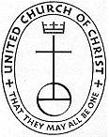

Stratham Community Church, UCC
6 Emery Lane - Stratham, New Hampshire 03885
(603) 772-3389 - www.strathamchurch.org
Ministers - The Congregation
Pastor – The Rev. Westley Conn – WestleyConn@strathamchurch.org
Music Director – John Bostron, MM – johnc.bostron@protonmail.com
Sunday School Coordinator – Judy George – george.judy03885@gmail.com
Church Office – Kristen Dusseault – findfaith@strathamchurch.org



The Stratham Community Church is open for worship on Sundays at 10am.
We house both a preschool and thrift shop in our building.
For more information, please visit our website.

